**Project Design Phase-II**

**Data Flow Diagram & User Stories**

|  |  |
| --- | --- |
| Date | 15 October 2022 |
| Team ID | PNT2022TMID11609 |
| Project Name | PROJECT-Personal Expense Tracker |
| Maximum Marks | 4 Marks |

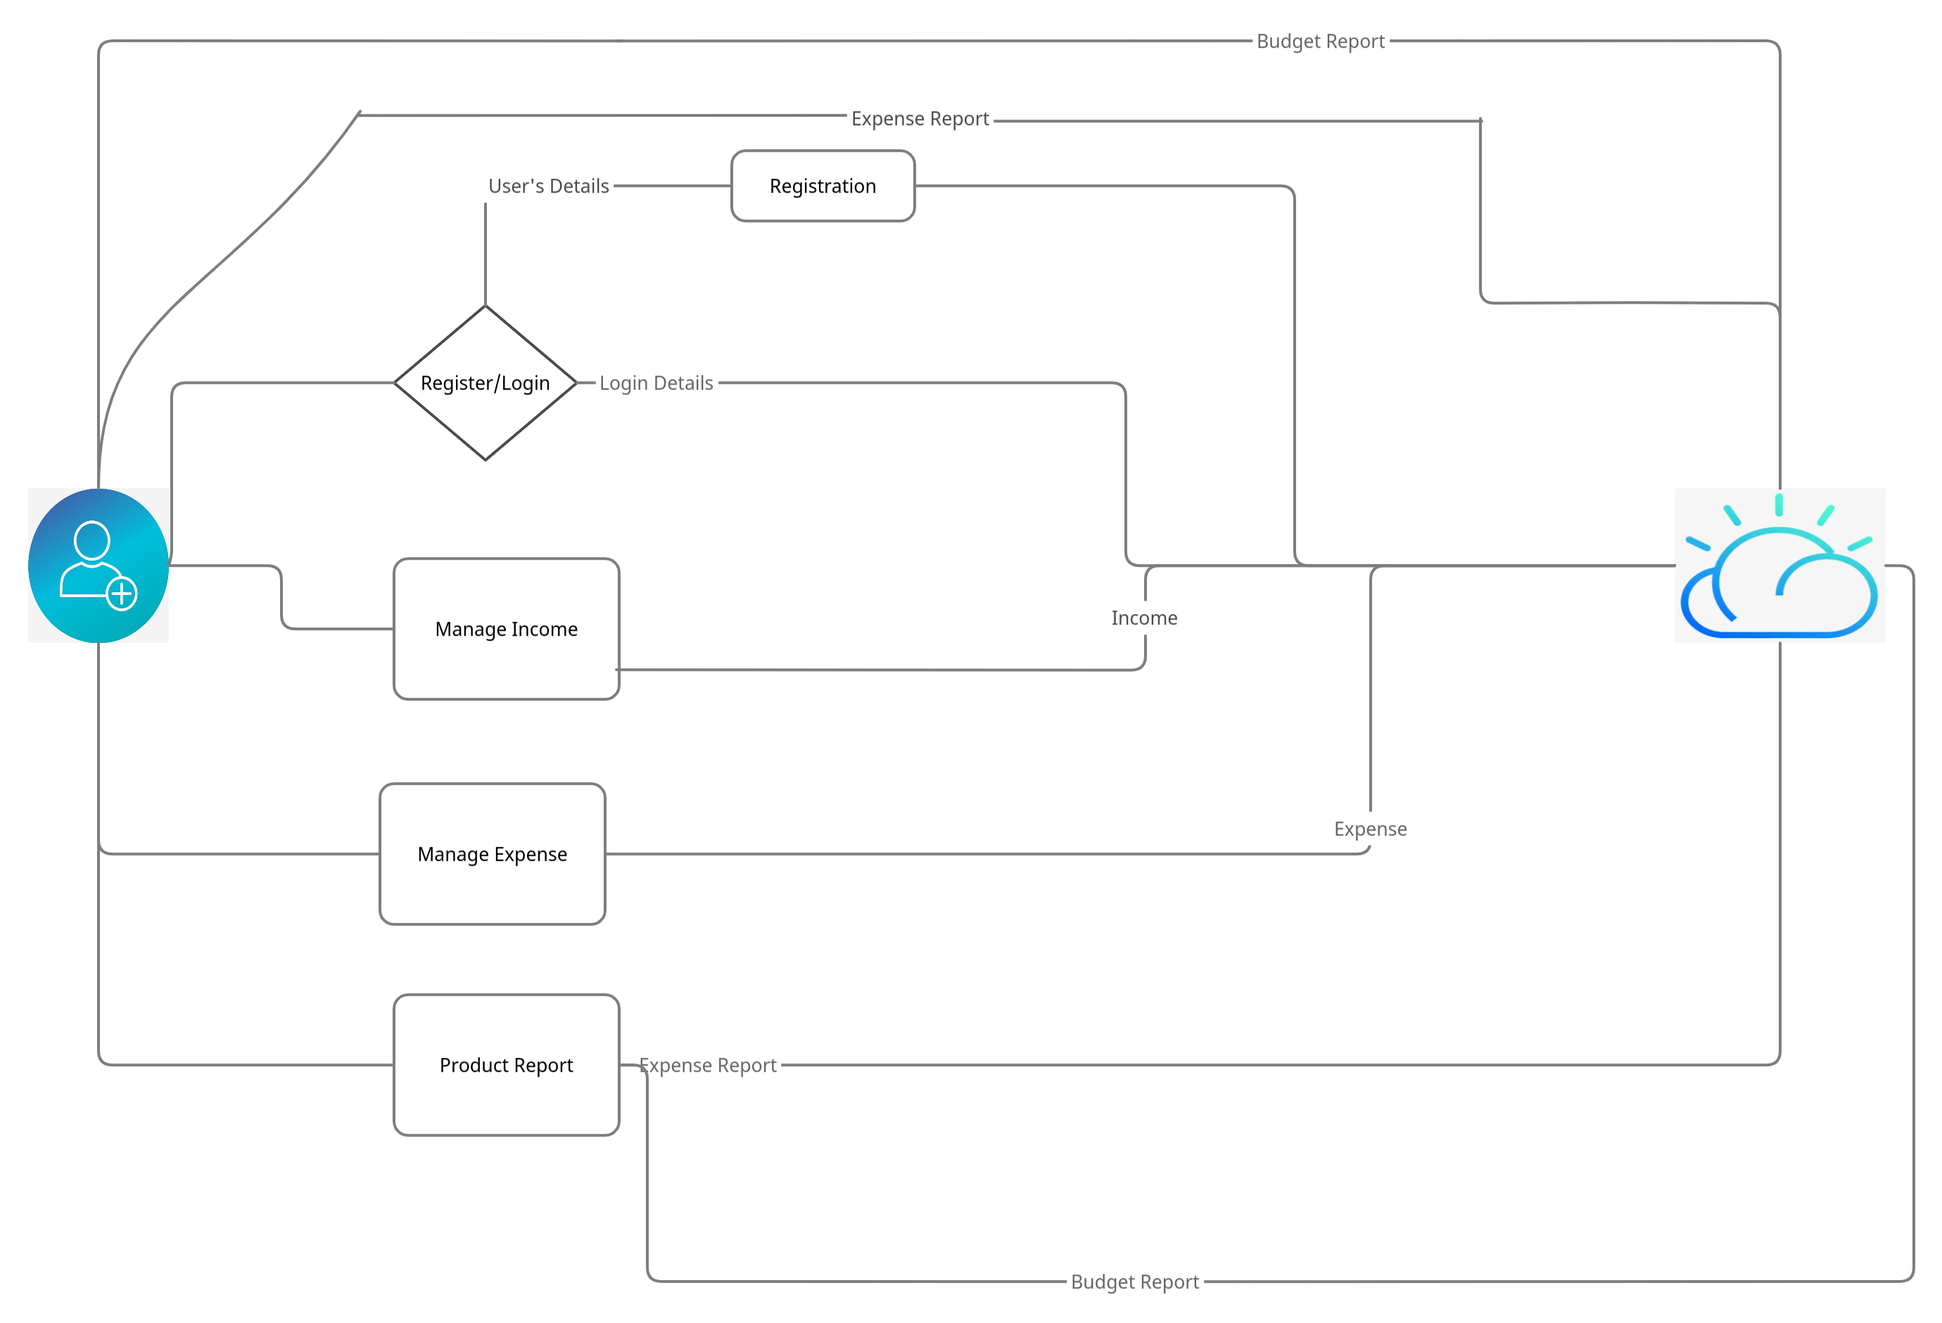**Data Flow Diagrams:**

**User Stories**

Use the below template to list all the user stories for the product.

| **User Type** | **Functional Requirement (Epic)** | **User Story Number** | **User Story / Task** | **Acceptance criteria** | **Priority** | **Release** |
| --- | --- | --- | --- | --- | --- | --- |
| Customer (Mobile user) | Registration | USN-1 | As a user, I can register for the application by entering my email, password, and confirming my password. | I can access my account / dashboard | High | Sprint-1 |
|  |  | USN-2 | As a user, I will receive confirmation email once I have registered for the application | I can receive confirmation email & click confirm | High | Sprint-1 |
|  |  | USN-3 | As a user, I can register for the application through Facebook | I can register & access the dashboard with Facebook Login | Low | Sprint-2 |
|  |  | USN-4 | As a user, I can register for the application through Gmail |  | Medium | Sprint-1 |
|  | Login | USN-5 | As a user, I can log into the application by entering email & password |  | High | Sprint-1 |
|  | Dashboard | USN-6 | As a User, I can access my application,Manage the expense,add budget,expense report from the app and etc. |  | High | Sprint-1 |
| Customer Care Executive | Email or Customer Care Number | USN-7 | As a User, I can contact the service administration for the support | I can solve the Issue | Medium | Sprint-3 |
| Administrator | Email or Customer Care Number | USN-8 | As a User, I can contact the service administration for the support | I can solve the Issue | Medium | Sprint-1 |